Module 1

In the context of C programming and algorithm analysis, understanding problem instances, generalization, classification, and analysis is crucial for designing efficient and robust solutions. Problem instances are specific inputs that a program or algorithm needs to solve. Generalization involves creating broader categories or types of solutions that can handle various problem instances. Classification groups similar problem instances based on shared characteristics, while analysis examines the complexity and efficiency of different approaches. In more details, let’s understand these terms
1. Problem Instances:
- A problem instance is a specific input that an algorithm or program needs to process to produce a solution.
- For example, if the problem is "sorting a list of numbers," a problem instance would be a particular list of numbers, like.
- Different instances of the same problem can have different characteristics, like size, number of elements, or the presence of duplicates.
2. Generalization:
- Generalization involves creating more abstract or broad types of solutions that can handle multiple related problem instances.
- It's about finding commonalities and patterns across different instances and creating a solution that works for all of them.
- In C, generalization can be achieved through function pointers, templates, or abstract base classes, allowing you to write code that can handle different data types or algorithms.
3. Classification:
- Classification is the process of grouping problem instances into categories based on shared characteristics.
- This helps in understanding the structure of the problem and choosing the appropriate solution approach.
- For example, sorting algorithms can be classified based on their time complexity (e.g., O(n log n) vs. O(n^2)) or the data structures they use (e.g., comparison-based sorting vs. non-comparison-based sorting).
4. Analysis:
- Analysis involves examining the efficiency and complexity of different solution approaches.
- It helps in choosing the most suitable algorithm or data structure for a given problem instance or class of instances.
- In C, you can analyze algorithms using techniques like time complexity analysis (Big O notation), space complexity analysis, and worst-case, average-case, and best-case scenarios.
Example:
Consider the problem of finding the maximum value in an array.
- Problem Instance:
An array of numbers, such as [5, 2, 8, 1, 9].
- Generalization:
A function that can find the maximum value in any array, regardless of its size or the data type of its elements (using a generic type like void* or templates in C++).
- Classification:
The function could be classified based on its efficiency, like being a simple linear search algorithm (O(n)) or a more efficient approach using a min/max heap (O(n) or O(log n) depending on the implementation).
- Analysis:
You would analyze the time and space complexity of different approaches to find the maximum value, comparing their performance on different input sizes and data distributions.

In summary, understanding problem instances, generalization, classification, and analysis is essential for designing effective C programs and algorithms that can handle various inputs and achieve desired performance goals.

Computers are used in modern life in a number of ways. They are used to store data for us, to solve problems for us, to play music and videos for us, to communicate with our friends and so on. The list is endless. A stage is reached where people tend to call it as “The Electronic Brains”. This is a misconception because as known a computer does not do anything by itself it just diligently follows the instructions provided by us to solve a given problem or to perform any other task.

A major area where computer can be used is to assist people in solving problems that are beyond human capabilities. People could never perform very long sequence of computations in engineering and mathematics because humans are prone to errors and are normally slow in their calculations. Manual calculation of finding the stress in an airplane wing for example would be out of question. Designers of planes can easily make basic decisions about the style of the wing; the computer helps in analyzing how stresses affect the wings in a practical length of time.

It is not important to use a computer to solve only one problem. The effort of writing a program should always help in solving a number of similar problems. It would not be worthwhile to write a program to process one bank account but such a program is economically justified if all bank transactions can be processed automatically. Therefore, when we write computer programs, we write it to solve a set of problems not just one.

Problem solving can be defined as “The task of expressing the solution of complex problems in terms of simple operations understood by the computer”.

Problem solving using a computer will thus require us to follow a well-defined sequence of steps in a systematic manner. In order to solve a problem using a computer we will have to pass through certain stages. The stages are:

- Problem definition.
- Problem analysis.
- Design of a solution using design tools such as Flowcharts and Algorithms.
- Programming the computer (Coding).
- Checking and correcting errors (Testing and Debugging)

After these main stages, the documentation is created and further program enhancement or maintenance performed.

PROBLEM DEFINITION

The basic concept, which should be clearly understood, is that “Success can be achieved in problem solving only when we know what we want to do”, i.e., the problem should be clearly understood first by the user. A proper involvement in this process always helps in generating a good workable solution. We cannot make any progress if we do not understand the problem. In this step of problem solving, we analyze what must be done rather than how to do it. Most programmers overlook this activity and these results in shabby solutions to problems.
Problem definition requires us to develop exact specification of the problem. In other words, we must try to extract from the problem statement a set of precisely defined tasks. The problem definition should be in the users’ language such as English or some other natural language. It may include charts, tables and equations of different kinds. The exact notation used depends on the problem area. Knowledge about this can be gathered using certain techniques such as observation of the actual task, interviews and so on.

Example 1.1: Suppose we have a set of visiting cards, each card containing a name, address and a telephone number. The problem is to find the telephone number corresponding to any given name.

In the first stage of problem solving, it is necessary for us to be more precise about the structure of the input data. We may want to know whether the visiting cards are arranged

in alphabetic order of names or are they in a random order. We will assume that the cards are not in order but we can lead through the cards one at a time from the first to last. Next, we must also decide what action we would perform if the name were not present in any of the visiting cards. The problem was not precisely defined because it did not tell us about this.

Therefore, we correct the problem statement by indicating that the output should be either the phone number of the person or a message that the name is not present.

Example 1.2: We are to compute the square root of a number as a decimal number using only the operations of addition, subtraction, multiplication and comparison.

Initially we are confronted with the problem of understanding what is meant by square root. Taking certain examples, we may know that the square root of 4 is 2 and the square root of 9 is 3. In general, we may say that the square root of n is another number m such that it satisfies the equation:
n=m * m

The problem statement can be modified to represent the following steps

- Start with a number “m” which is less than the number “n”
- Square “m” and compare it with “n”. If the value is greater than “n” decreases the
value of “m” by a small amount and repeat step 2 otherwise go to step 3.
- If the square of “m” is less than “n” then increase the value of “m” by a small amount (say about 0.01). Again, find the square of “m” and compare it with “n”.
- Repeat step 3 until we have computed the square root we required to the desired accuracy.

PROBLEM ANALYSIS

In problem analysis we try to understand the requirements of the problem to be solved. This process is the first step towards the solution domain. Explicit requirements about the input – output, time constraints, processing requirements, accuracy, memory limitations, error handling and interfaces are understood at this stage. The end result of this analysis is the selection of a method, which is to be used on the computer or a decision that a computer should not be used because of constraints as it may be seen that manual methods are better.

To completely and properly specify the input to a program we may have to answer certain questions such as:

- What are the values, which should be provided to the program?
- What is the order in which the input is to be provided?
- What is the format of certain types of data (such as date)?
- What is the accuracy of the input data?
- What is the input device?
- What is the range of values allowed for a particular input?

Similarly, to provide the output of a program we may have to answer certain question such as:

- What are the outputs generated by the program?
(The outputs should be clearly and unambiguously specified).
- What is the format of the outputs?
(Which includes type, accuracy and the units)
- What is the output device?
- How the outputs should be displayed? (Which includes spacing, layout and heading)

Example 1.3: Telephone number search problem
In the analysis of the problem, we decide that the only reasonable method given the structure of the input data is to look at each card one after the other and compare the name it contains with the name being searched. If the card is found we stop and report the output otherwise we continue with the remaining cards one after the other if we reach the end of the cards without finding the name, we output the message that the name is not present.

Example 1.4: Finding the square root of a number
The steps of solving this problem have been clearly understood in the previous stage. In this stage we understand that the basic operations required in solving the problem includes addition, subtraction and multiplication. The method described could be easily applied to any positive integer to find the approximate square root. The answer generated after the operation is to be displayed with appropriate heading and layout so that it is clearly understood.

DESIGN OF PROBLEM SOLUTIONS AND USE OF DESIGN TOOLS

Once the process of problem definition and problem analysis is complete it is necessary for us to define the solution to the problem. The solution should include a sequence of well- defined steps that will input and manipulate the data and produce the desired output. The process of good designing can be done efficiently with the choice of certain design tools. Algorithms and flowcharts are two design tools, which help in the representation of a solution to a problem.

Complex problems can be effectively solved using the computer when they are broken down into sub-problems. Sub-problems are easier to solve than the complete problem. This approach sometimes called as divide and conquer, can be applied to the construction of the problem solution and to the writing of the computer program.
Consider the problem of finding the area of a triangle. This problem can be divided into three sub-problems

    - Input the data
    - Compute the area and
    - Output the results.

Area of a triangle
Input the data
Compute thearea
Output theresults
Figure 1.1 Design of solution for area of triangle problem

Now we have reduced the solution of the original problem to three simpler sub-problems. We proceed to refineeach sub-problem to obtainamore detailedsolution.

Subproblem | Refinement
Input the height and the base of the triangle.
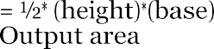

We now have sufficient detail to implement a computer solution. This approach of dividing a problem into sub-problems, and then dividing the sub-problems further until they can be implemented for computer solution, is called top-down design. The process of refining the solution of a problem at each stage is called as stepwise refinement. Although the triangle area problem is a simple case, the power and effectiveness of top-down design will become evident when we attack more complicated problems. At this point, it is highly recommended that the student apply top-down design to all problems for computer solution.
Some of the advantages of top-down design are:

- The problem is easily understood and can be logically organized into parts called
modules. Thus, there is a structure to the solution of the problem.
- Modifications or changes can be easily made to the modules.
- Testing the solution can be easily performed.

Let us return to the triangle area problem and consider top-down design as represented by a tree diagram.
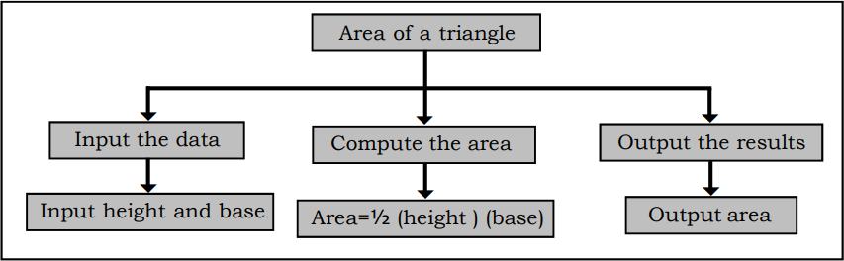

Figure 1.2 Refinement of a triangle area problem

The top-down design is an outline of the solution to the problem. The solution must be translated to a computer language. Observe that in the top-down design we start with the general description of the problem and then refine at each level until the solution is detailed enough for translation to a computer language. This process is also called algorithm-design, since we are actually designing the problem solution or algorithms.

ALGORITHMS
An algorithm is a step-by-step procedure to solve a given problem. The word algorithm is derived from the name of a 9th century Arab mathematician, Al-Khowarizmi, who developed methods for solving problems which used specific step-by-step instructions.

Definition
The essential characteristics of an algorithm are:

- Every step of an algorithm should perform a single task.
- Ambiguity (Confusion) should not be included at any stage in an algorithm.
- An algorithm should involve a finite number of steps to arrive at a solution.
- Simple statement and structures should be used in the development of the algorithm.
- Every algorithm should lead to a unique solution of the problem.
- An algorithm should have the capability to handle some unexpected situations, which may arise during the solution of a problem (For example, division by zero).

Example 1.5: An algorithm to find the area of a triangle can be expressed as follows:
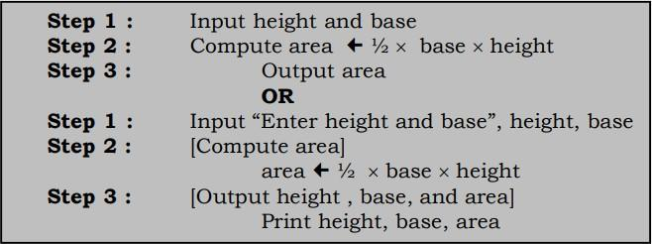

This algorithm is specific enoughto be translated into acomputer language, such as C. Note that there is an order to the steps created i.e., Step 1 is performed first, followed by Step
2, and finally Step 3. Once the computer program is written, the computer can execute these instructions in order.

To show you a comparison between algorithm instructions and high-level language statements, the following table lists the three steps of the triangle area algorithm and the corresponding C statements
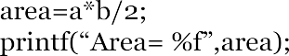
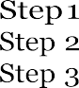

Compute area = ½ (height)(base) Output area
C statements
Algorithm
Steps

Algorithms may be developed for any type of problems; mathematical or scientific or business. Normally, algorithms for mathematical and scientific problems involve mathematical formula, but algorithms for business problems are generally descriptive and have little use of formulas.

Steps Involved in developing an algorithm

- Clearly understand the problem statement so that a proper algorithm can be evolved.
- Study the outputs to be generated so that the input can be specified.
- Design the process, which will produce the desired result after taking the input.
- Refine the process.
- Test the algorithm by giving the test data and see if the desired output is generated. If not, make appropriate changes in the process and repeat the process.

Advantages of algorithm

- It is a step-by-step representation of a solution to a given problem, which is very easy to understand.
- It has got a definite procedure, which can be executed within a set period of time.
- It is easy to first develop an algorithm, and then convert it into a flowchart and then into a computer program.
- It is independent of programming language.
- It is easy to debug as every step has got its own logical sequence.

Disadvantages of algorithm

It is time consuming and cumbersome as an algorithm is developed first which is converted into a flowchart and then into a computer program.

Example 1.6: Design an algorithm to calculate the Simple interest, given the principal (P), rate (R) and time (T).
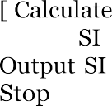

Step 1 :
Step 2 :
Step 3 :

Step 4 :
Step 5 :

Example 1.7 : Design an algorithm to find the average of four numbers.

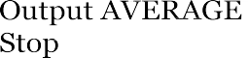

Step 1 :
Step 2 :
Step 3 :

Step 4 :
Step 5 :

Example 1.8 : Design an algorithm to find the largest of three numbers.
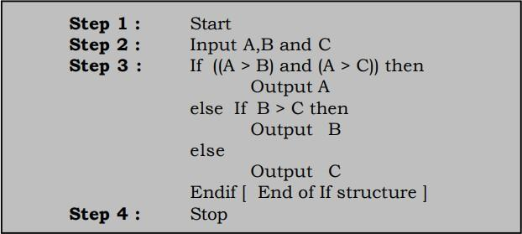
Example 1.9 : Design an algorithm to print all numbers from 1 to N.
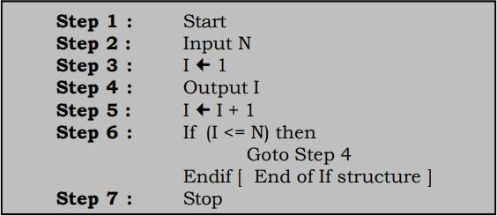

FLOWCHARTS
A flowchart is a pictorial or graphical representation of a solution to any problem. It indicates the process of solution, the relevant operations and computations, the point of decisions and other information as part of the solution. Flowcharts are constructed by using special geometrical symbols. Each symbol represents an activity. The activity could be either input or output of data, computation or processing of data, taking a decision or terminating the solution, and so on. The symbols used in a flowchart are joined by arrows.

Definition
Flowcharts are classified into two categories :
    - Program Flowcharts and
    - System Flowcharts.

Program Flowchart presents a diagrammatic representation of a sequence of instructions for solving a problem. In contrast, System Flowchart indicates the flow of data throughout a data processing system, as well as the flow into and out of the system. Such flowcharts are widely used by designers, to explain a data processing system.

.1 Steps Involved in developing Flowcharts

- Clearly understand the problem statement so that a proper flowchart can be evolved.
- Study the outputs to be generated so that the input can be specified.
- Design the process, which will produce the desired result after taking the input.
- Refine the process.
- Test the flowchart by giving the test data and see if the desired output is generated. If not, make appropriate changes in the process and repeat the process.

Symbols used in flowcharts
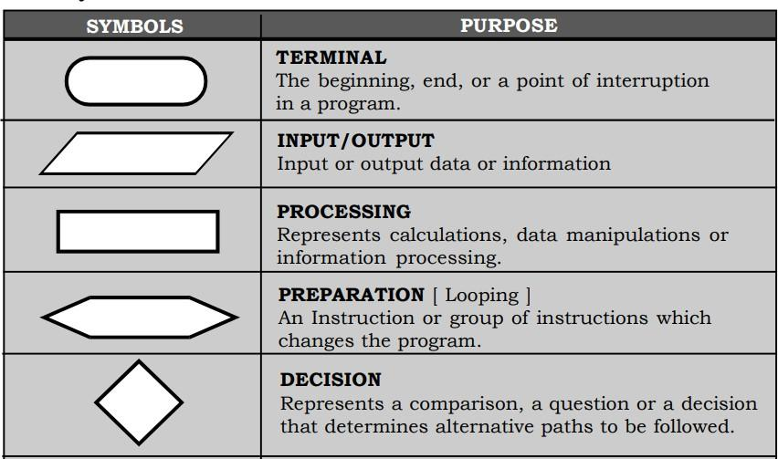
Table 1.1 Flowchart symbols

Advantages of flowcharts
- Flowcharts provide an excellent means of communication, which is very easy to understand.
- It has got a definite procedure, which shows all the major parts of a program.
- It is easy to convert it into a program.
- It is independent of programming language.
- It is easy to debug as every step has got its own logical sequence.

Disadvantages of flowcharts
- It is time consuming and cumbersome as it requires the uses of a number of symbols which are to be properly represented.
- The representation of a complex logic is very difficult in a flowchart.
- Alterations and modifications can be only made by only redrawing the flowchart.
Example 1.10: Design a flowchart and an algorithm to find the area of a square.
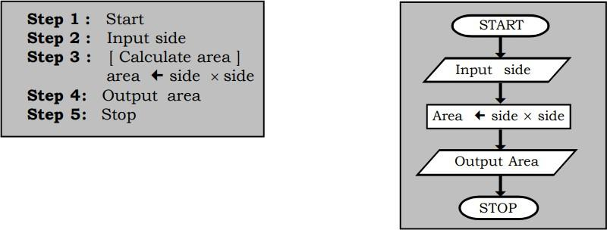

Example 1.11: Design a flowchart and an algorithm to find the area of a triangle given three sides.
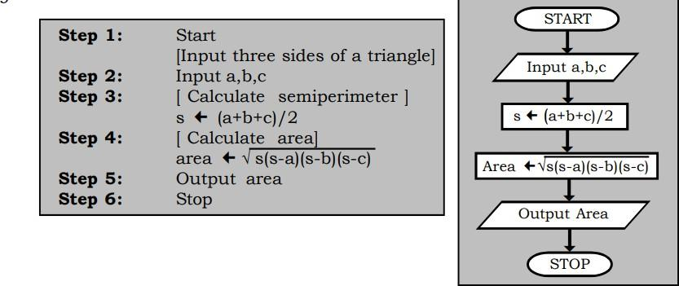
Example1.12 : Design aflowchartand an algorithm tofind thelargest of two numbers.
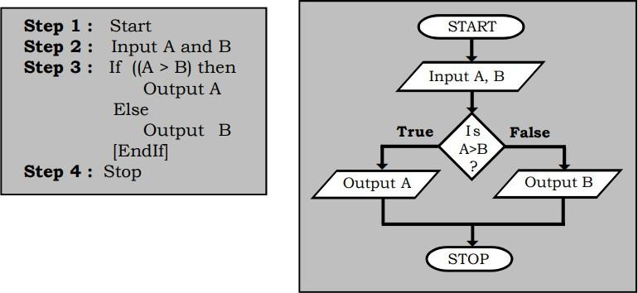

CODING
The process of converting the representation of a solution (either as an algorithm or flowchart) into a set of instructions in a programming language is referred to as coding.

Definition

Algorithms and flowcharts can be written in ordinary language or using formal procedures which are somewhere between ordinary and programming language because the emphasis is more on the representation of the solution and not on syntax. During coding the programmer takes each step converts it into a proper representation using proper syntax and logic. The process is said to be successful or complete when the compiled version does not generate any error.
Example:
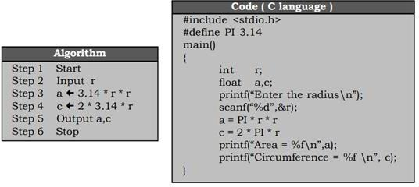

DEBUGGING

The process of detecting and correcting errors in a program is referred to as debugging. Very few programs run correctly for the first time. Thus debugging is a very important and time-consuming phase of software development. The process of debugging ensures that the program does what the programmer intends to do. This stage is also referred to as verification.

Definition

The process of debugging requires us to follow the following sequence of steps:
- The program is first compiled. During the process of compilation, the compiler detects certain types of errors called as syntax errors.
- All the detected errors are corrected and the program is recompiled. The process is
repeated till no errors are displayed.
- The program is then executed. During the execution of a program certain errors called as semantic errors are detected. Semantic errors normally occur due to the wrong use of logic.
- Once all the errors are corrected the program is recompiled again and executed.

The following terms can be associated with the process of debugging.

Compiler : It is a software, which checks the entire program created by the user for a certain type of error called as syntax errors. If the program is error free the complete program is translated to its equivalent machine language program.

Source : The program created by the user in a high level language is referred
program to as source program.

Object : The machine language program generated by the compiler is referred
program to as object program.

Syntax : It refers to the set of rules, which should be followed while creating every statement and structure in a program.

Syntax : An error, which occurs due to the wrong use of syntax, is referred to
error as syntax error.

Semantic : It refers to the logic, which is followed while representing a solution.

Semantic : An error, which occurs due to the wrong use of logic, is referred to as
errors semantic error.
Logic error: If the correct translation of an algorithm or flowchart causes the program to produce wrong results. Such error is referred to as logical errors.
Runtime : Errors, which are detected during the execution of a program, are
errors referred to as runtime errors.

Testing: It is the process of checking whether the program works correctly according to the requirements of the user, i.e., whether the program generates the correct results for a given input of data.
The correctness of the program can be determined by trying a large number of carefully chosen data and then by seeing if the program generates the correct output in all those cases. If debugging is referred to as verification, testing is referred to as validation.

Data representation in memory

In C, data types define the kind of data a variable can hold, influencing how the data is stored in memory and the operations that can be performed on it. C provides built-in data types like int, char, float, and double to handle different data types.

Basic/Primary Data Types:
- int:
Used to store whole numbers (integers). The amount of memory int uses can vary (2 or 4 bytes depending on the system), and it has a defined range of values.
- char:
Used to store single characters (letters, symbols, etc.). Characters are stored as their ASCII or Unicode values.
- float:
Used to store single-precision floating-point numbers (decimal numbers).
- double:
Used to store double-precision floating-point numbers (more precise decimal numbers than float).
- void:
Represents the absence of a type. It's often used for functions that don't return any value or for function arguments when no arguments are needed.

Derived and User-Defined Data Types:
- Arrays: Collections of elements of the same data type.
- Pointers: Variables that store memory addresses.
- Structures: User-defined data types that can group together variables of different data types.
- Unions: Similar to structures but all members share the same memory location.
- Enumerations: User-defined data types that represent a set of named integer constants.

How Data is Stored in Memory:
- Memory Layout: C programs have different segments in memory: text (code), data (global/static variables), BSS (uninitialized global/static variables), stack (local variables), and heap (dynamically allocated memory).
- Integers: Stored as binary numbers, with the size depending on the int type.
- Characters: Stored as their ASCII or Unicode values.
- Floating-Point Numbers: Stored in a format that can represent both whole and fractional parts (like IEEE 754).

Format Specifiers: When printing variables using functions like printf, you need to use the correct format specifier to interpret the data correctly (e.g., %d for int, %c for char, %f for float).
Type Conversion: C allows you to convert variables from one data type to another (e.g., converting an integer to a floating-point number).
